**CCNA: - (CISCO CERTIFIED NETWORKING ASOCIATION)**

**-: INTRODUCTION:-**

* Networking is a collection of computers connected to each other.
* It allows the computers to communication with each other.
* Connected computers can share resources which include information software and peripheral devices.

**-:ADVANTAGES:-**

* Enable user to share hardware like scanner and printer. This reduce cost by reducing the number of hardware items bought.
* Allows users access to data stored on other computer.
* Can even let users run programs that are not installed on their own computer bus are installed else where in the network.

**-: DISADVANTAGES :-**

* Accessing anything across a network is slower than accessing your own computer.
* More complexity adds new problems to handle.
* **TYPES OF COMPUTER NETWORKING :-**

**LAN (LOCAL AREA NETWORK)**

A LAN is a local area network. This would include network where the computer is relatively close together.

LAN would be within the same office a single building or several building close together.

**WAN (WIDE AREA NETWORK)**

WAN cover a large geographical area.

WANs are mostly user leased lines or public phones lines as their backbone.

**-: CLIENT/ SERVER: -**

* **CLIENT: -** To access services from server.
* **SERVER: -** To provide services to client.

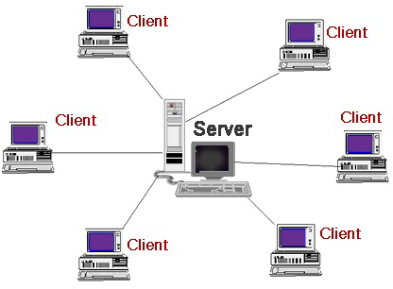

**-: TOPOLOGY:-**

The actual layout of a network and its media is called topology.

**FACTORS: -**

* Cost
* Scalability
* Bandwidth capacity.
* Ease of installation.
* Ease of fault finding and maintenance.

**-: TYPES OF TOPOLOGIES: -**

* **BUS: -**

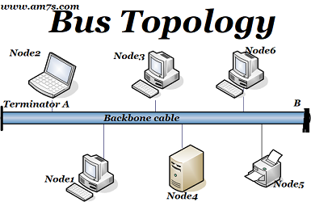

# ADVANTAGES: -

* Inexpensive to install.
* Easy to add station
* Use less cable than other topologies.
* Works well for small networks.

# DISADVANTAGES: -

* No longer recommended
* Backbone brake, whole network down
* Limited no. of devices can be attached.
* Difficult to isolated problem.
* Sharing same cable slows response rate.

**RING TOPOLOGY: -**

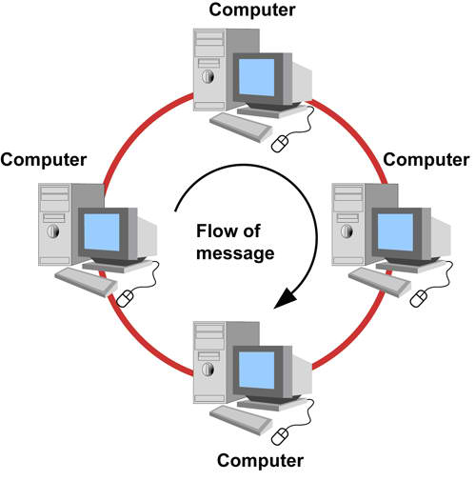

**-: DUAL RING TOPOLOGY: -**

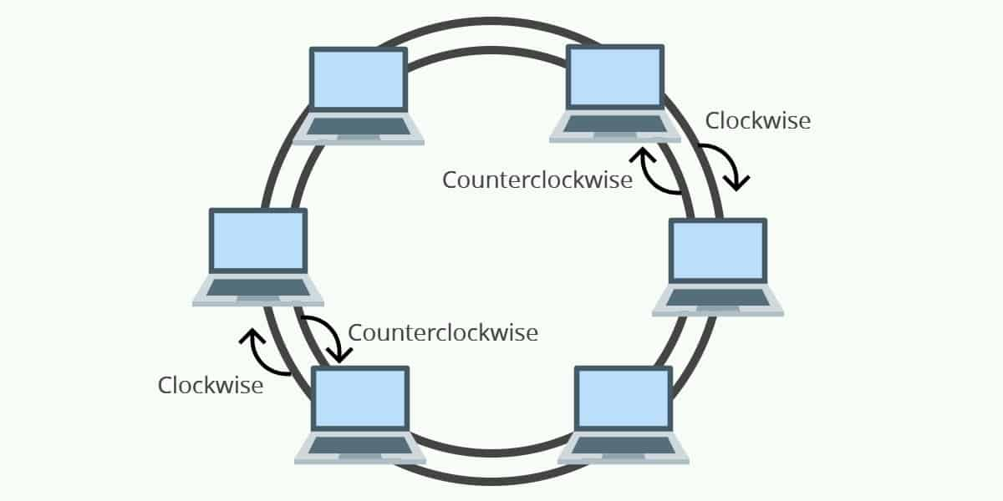

* Each device has to wait its turn to transmit.
* Most common type is token ring (IEEE 802.5)
* A token contain is data, reaches the destination data extracted.
* Empty token passed on for another device to use.

# ADVANTAGES: -

* Data packed travel at great speed.
* No collision
* Easier to fault find.
* No terminator required.

# DISADVANTAGES: -

* Requires more cable than a bus.
* A brake in the ring will bring it down.
* Not as common as the bus-less devices available.

# STAR TOPOLOGY: -

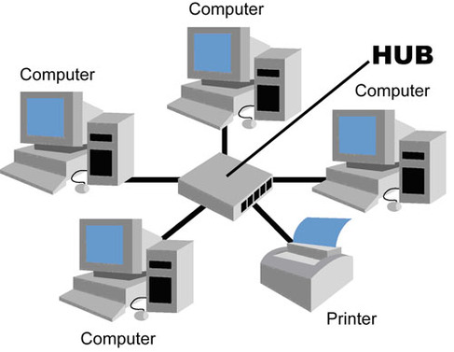

* Centre point is a hub/ switch.
* Segment meets at the hub.
* Each device needs its own cable to the hub.
* Easy to maintain and expand.

# ADVANTAGES: -

* Easy to add devices as the network expands.
* One cable failure does not bring down the entire network.
* Easy to find devices and cable problem.
* Can be upgraded to faster speed.

# DISADVANTAGES: -

* A star network requires more cable than a ring or bus network.
* Failure of the central hub can bring down the entire network.
* Cost are higher installation and equipment the most bus network.
* **TREE TOPOLOGY: -**

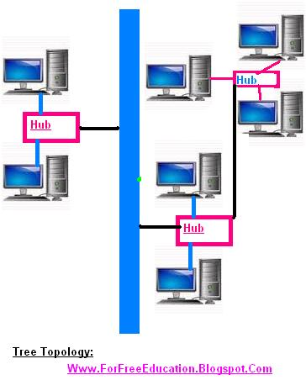

* **MESH TOPOLOGY: -**

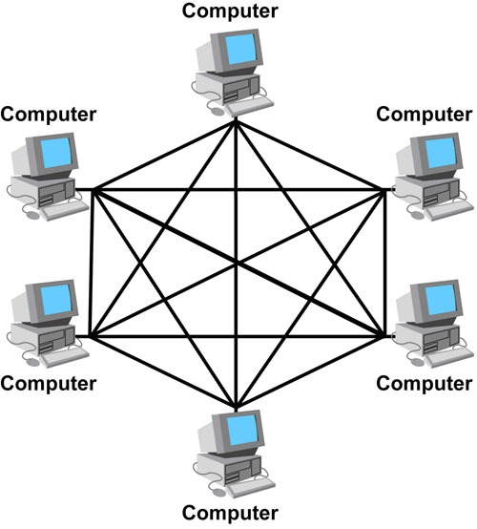

* Not common on LANs.
* Most often used In WANs to interconnect LAN’s.
* Each node is connected to every other nodes.
* Allows communication to continue in the event.
* It is fault tolerant.
* **ADVANTAGES: -**

1. improve fault tolerant.

* **DISADVANTAGES: -**

1. Expansive
2. Difficult to install
3. Difficult to manage
4. Difficult to trouble shoot.

* **HYBRID TOPOLOGY: -**

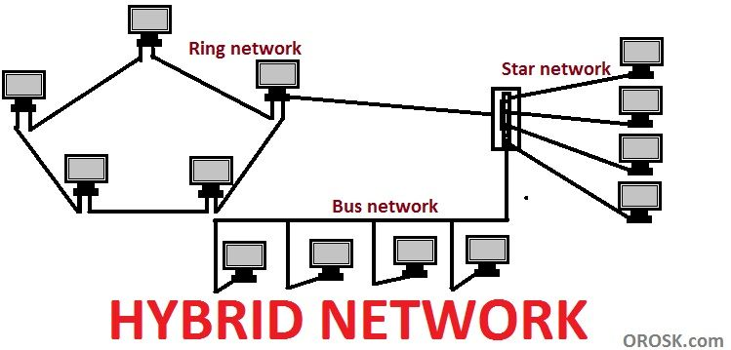

**-: NETWORK CABLE: -**

* Cable is the medium through which information usually moves from one network devices to another.
* There are several types of cable which are commonly used with LAN’s.
* The types of cable chosen for a network is related to the network’s topology protocol and size.
* Understanding the characteristics of different types of cable and how they related to other aspects of a network is necessary for the development of a successful network.

**-: CHARACTERSTICS OF CABLE: -**

**SEGMENT: -**

Defines the length of a signal wire attenuation: -

Attenuation is a general term that refers to any reduction in the strength of a signal. Attenuation occurs with any type of signal, whether digital or analogue sometimes called loss. Attenuation is a natural consequence of signal transmission over long distance.

**BANDWIDTH: -**

* Bandwidth is often used as a synonym for data transfer rate the amount of data that can be carried from one point to other in a given time period (usually a second)
* Number of segments
* Defines the maximum number of segments in a network.
* Interference susceptibility/ cross talk.
* A disturbance, caused by electromagnetic interference, along a circuit or a cable pair. A telecommunication signal disrupts a signal in an adjacent circuit and can, cause the signals to become confused and cross over each other.
* Cost.

**-: COAXIAL CABLE: -**

Co-axial cabling has a signal copper conductor at its centre. A plastic layer provides insulation between the centre conductor and a braided metal shield. The metal shield helps to block any outside interference from florescent lights, motors and other computer.

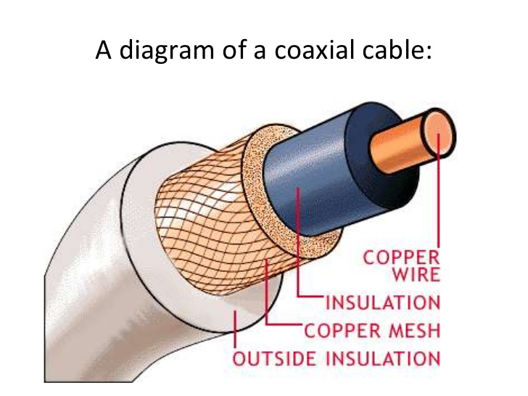

**-: INTERNETWORKING DEVICE: -**

Many devices help control and extend the usable size of a network as it grows.

These devices have a wide variety of function and are added to networks to accomplish the following objectives

Allows a greater number of computers to exist on the network.

Extend the useable distance of the network

Segment or localize traffic on the network

Subdivide the network so that problems are easier to isolate so that problems are easier to isolate.

Join exiting networks together.

**-: REPEATER: -**

Used to boost the signal between two cable segment or wireless access point.

Cannot connect different network architecture.

Does not simply amplify the signal it regenerates the packets and retimes them.

Resides on layer 1 of the OSI model.

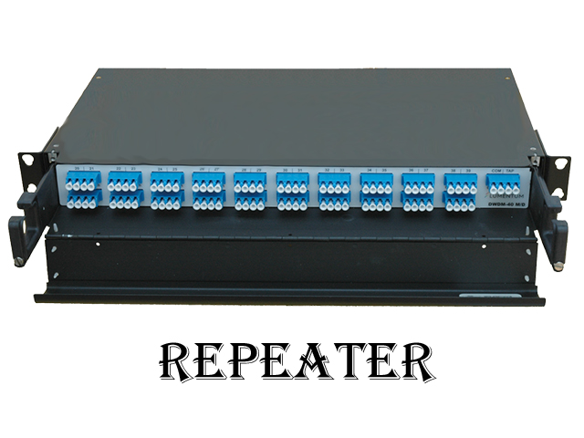

**-: HUB: -**

An unintelligent network device that sends one signals to all the stations connected to it.

Traditionally, hub is used for star topology networks

Resides on layer 1 of OSI model.

It is LAN or same network connectivity device.

Hub operators’ layer 1 of OSI model.

It works in half duplex mode means only two devices can communication at a time one can send the data and another can receive the data.

It divides the transmission speed because it uses broadcast to make communication.

It is also called multiport repeater.

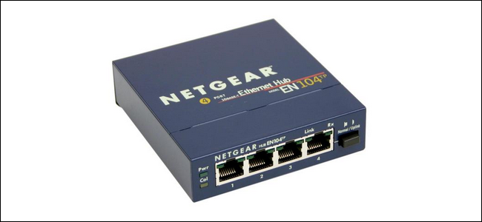

**-: BRIDGE :-**

Connects two LAN’s and forwards or filters data packet between them.

Create an extended networks in which are two workstations on the linked LAN’s can share data.

Forward data depending on the hardware (MAC) address, not the network address (IP)

Resides on layer 2 of the OSI model.

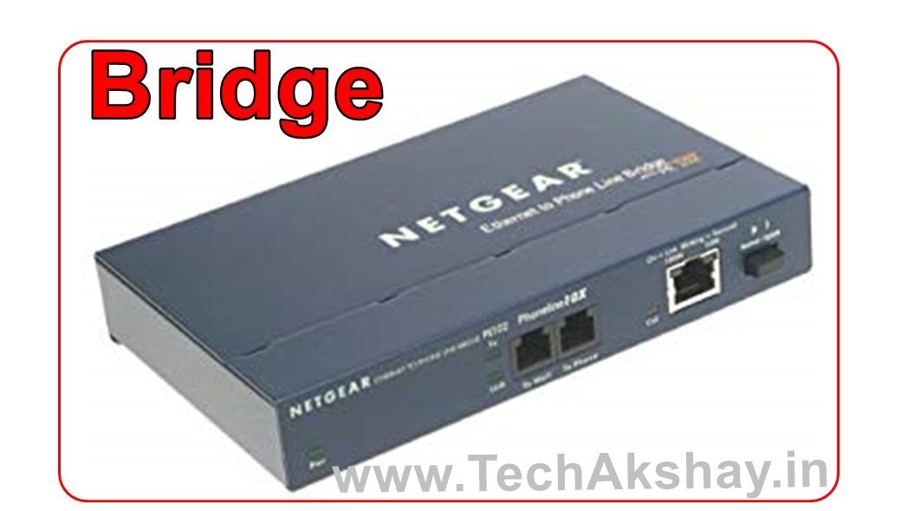

**-: SWITCH :-**

A multi-input multi output devices that transfers packets from on input to an output.

The number of ports on a switch determine the number of hosts that can be connected

Larger number of hosts can be interconnected by interconnecting switches

Adding a new host does not limit or reduce the performance of other hosts.

It is also LAN or same network connectivity device

Switch operates layer 2 (data link layer) of OSI model. It understands the mac address. And forward the frame according to mac address.

It works in full duplex mode means device can send and receive data simultaneously .

It provides wired speed

It user hardware chip ASIC(application specific integrated circuit) to create mac address table.

It is also called multiport bridge.

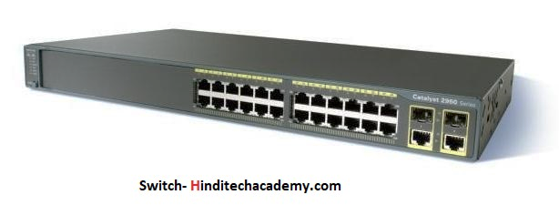

**-: ROUTER :-**

A router is a device or a software in a computer that determines the next network point to which a packet should be forwarded toward its destination.

Routers make smart devices on how to route (or send) packets.

It connects two or more network segment which may be near or very far and having different type of cabling.

Router has LAN ports which are used to connect to your LAN or computers and one or more WAN port.

The WAN port is generally used to connect the some other connection that links to regular phone line, a more advanced connection like ISDN, ADSL, T1 or may be a cable modem.

Router comes in variety of shapes, sizes and function.

Little router (link sys, Motorola, Net gear, D- link) are used in homes and small business.

Big organization user sophisticated routers (CISCO etc).

It can work on LAN, MAN and WAN environments.

Routers pass the incoming packets from one LAN to another according to the IP addresses stored in the incoming packet.

A router creates and maintain a table of the available routes and their conditions and uses this information along with distance and cost algorithms to determine the best route.

A packet will travel through a number of network point with routers before arriving at its destination.

**-: OPRATION OF ROUTER :-**

Router checks the destination address of the received packet. Depending upon the destination router selects the best route for the packet from the routing table.

It builds a new frame around the packet and sends it to another network segment.

For routing decision router uses some algorithms called routing protocol.

Router share its own routing table information with other routers in the network. This enables routers to update their information.

**-: GATE WAY :-**

A gateway is a network point that acts as an entrance to another network.

The gateway node often acts as a proxy and firewall. A router can also act as a gateway.

Gateway works at all level of OSI model.

Gateways can connect networks with different protocols like TCP/IP network and IPX/SPX networks

Routers and gateways often refer to the same devices.

Gateway interconnects different networks and provides a translation services from one protocol stack to another.

The defaults gateway is simply a gateway that meets certain criteria.

* It is on the same subnet as your computer.
* It is the gateway that your computer depends upon when it does not know through which route to send the traffic.

**-: BACKBONE :-**

Backbone is central segment to which other segments are connected. This central segment provides connectivity to all the users in the network.

Users from one segment can communication with other through the backbone segment.

Mostly backbone have higher speed than the segments.

**-: IP ADDRESS :-**

* IP addressing is logical addressing.
* It works on network layer (layer 3)
* Two version of addressing scheme
  + Ip version 4 -32 bit addressing
  + Ip version 6 – 128 bit addressing

**IP VERSION 4 (IPV4)**

* WHAT IS BIT ?

Bit is a value that will represent 0s or 1s (i.e. binary).

# 01010011100011011000111100101001

32 bits are divides into 4 octets known as dotted decimal nation.

# 01011110**.**10100101**.**00001111**.**10011001

**IP VERSION 6 (IPV6)**

128 bit address is divided along 16 bit boundaries and each 16 bit block is covered to a 4 digit hexadecimal number and separated by colons (colon-hexa-decimal)

### FADC**:**BA98**:**7654**:**3210**:**FADC**:**BA98**:**7694**:**3210

**-: BINARY TO DECIMAL CONVERSION :-**

Taking example for first octet:-

Total 8 bit, value will be 0s ­and ­­­1s ­

e.g. 28 = 256 combination

27  26 25 24 23 22 21 20

0 0 0 0 0 0 0 0 = 0

0 0 0 0 0 0 0 1 = 1

0 0 0 0 0 0 1 0 = 2

0 0 0 0 0 0 1 1 = 3

0 0 0 0 0 1 0 0 = 4

1 1 1 1 1 1 1 1 = 255

**-: IP ADDRESS CLASSES :-**

**Class A :- 0-127 [ N.H.H.H ]**

**Class B :- 128- 191 [ N.N.H.H ]** LAN & VAN

**Class C :- 192 – 223 [ N.N.N.H ]**

**Class D :- 224 – 239 --** news group & broadcast

**Class E :- 240 – 255 ---=** researches & development

127 :- loopback address (trouble shooting)

**CLASS A :-**

Total no. of. N/W =128

Total no. of. Host = 256*256*256

= 16777216

Total no. of. Valid IP address = 16777216-2

= 16777214

e.g. 10.0.0.0 :- network address.

10.255.255.255 –broadcast address.

**CLASS B :-**

Total no. of n/w = 64*256

= 16384

Total no. of host = 256*256

= 65536

Total no. of valid host = 65536-2

= 65534

**CLASS C :-**

Total no. of n/w = 32*256*256

= 2097152

Total no. of host = 256

Total no. of valid host = 256-2

= 254

**-: octet format :-**

IP address is divided into network & host portion.

Class A is written as N.H.H.H

Class B is written as N.N.H.H

Class C is written as N.N.N.H

**Network & broadcast address.**

* The network address is represented with all bits as zero in the host portion of the address.
* The broadcast address is represented with all bits as ones in the host portion of the address.
* Valid IP addresses lie between the network address and the broadcast addresses.
* Only valid IP addresses are assigned to hosts/ clients.

**-: PRIVATE IP ADDRESS :-**

There are certain addresses in each class of IP address that are reserved for LAN. These addresses are called private addresses.

They can be used for home & office networks ATM machine, networks not connected to internet.

**Class A**

10.0.0.0 to 10.255.255.255

**Class B**

172.16.0.0 to 172.31.255.255

**Class C**

192.168.0.0 to 192.168.255.255

**-: SUBNET MASK :-**

Subnet mask differentiates networks portion and host portion.

Subnet mask is been given for host identification of network ID.

Represent all network bit value with 1

Represent all host bit value with 0

**-: ISO/OSI MODEL :-**

Open system interconnection model is fundamental to all communication between network device.

Developed in 1974 by ISO after the American department to defence began using the TCP/IP suite of protocols finally adopted in 1977. It is now the theoretical model for how communication takes place between devices.

**7 LAYER MODEL**

Physical layer

Data-link layer

Network layer

Transport layer

Session layer

Presentation

Application

**-: LAYERS :-**

Each layer is separate and independent.

Each has its own function, but also provide a service to those layers above and below itself.

When communicating each OSI layers takes with the same layer in the other device for example the application layer of device.

A communicates with the application layer of device B, by passing the data through the other layers.

The application layer of each device is not connected with how the other layers are functioning, but it does rely on them to do this job.

**-: APPLICATION LAYER :-**

* Make data presentable.
* The presentation layer ensure that the information that the application layer of one system sends out is readable by the application layer of another system.
* If necessary the presentation layer translate between multiple data formats by using a common format.
* Provides encryption and compression of data.

**-: SESSION LAYER :-**

Primarily responsible for handling the session between devices.

* (beginning, maintaining and finishing)

Enforces order in the communication between device

Regulates the flow of data

Session layer provides mechanism for controlling the dialogue between the two end system. It defines how to start control and end conversations (called session) between application.

This layer request for a logical connection to be established on an end user’s request .

Any necessary log on or password validation is also handled by this layer.

This layer provide services like dialogue discipline which can be full duplex or half duplex.

Session layer can also provides check pointing mechanism such that if a failure of some sort occurs between check points all data can be retransmitted from the last check point.

**-: TRANSPORT LAYER :-**

* Ensures reliable transport of packets from source to destination.
* Also manage the speed of transmission-flow control.
* There are two types of transmission (connection oriented transmission and connectionless transmission)
* Purpose of this layer is to provide a reliable mechanism for the exchange of data between two processes in different computer
* Ensure that data units are delivered in sequence.
* Ensure that there is no loss or duplication of data unit.
* Provides connectionless or connection oriented service.

**-: TCP/UDP**

|  |  |
| --- | --- |
| TCP | UDP |
| Transmission control protocol | User datagram protocol |
| Connection oriented | Connection less |
| Acknowledgement | No Acknowledgement |
| Reliable | Unreliable |
| Slower | Faster |
| Port no. 6 | Port No. 17 |
| e.g. HTTP,FTP,SMTP | e.g. DNS, DHCP,TFTP |

**-: PROTOCOL NUMBER :-**

SERVICES PROTOCOL NUMBER

* Internet control massage protocol (ICMP) 1
* Transmission control protocol ( TCP) 6
* User datagram protocol (UDP) 17
* Internet group management protocol (IGMP) 88
* Exterior gateway protocol(EGP) 8
* Open shortest path first (OSPF) 89
* Reliable datagram protocol (RDP) 27

**-: NETWORK :-**

* Defines end to end delivery of packets
* Defines logical addressing so that any endpoint can be identified
* Defines how routing works and how routes are teamed so that the packets to accommodate different media.

**-: DATA-LINK LAYER :-**

Has two sub layer of its own

* Logical link control (LLC)
* Media access control (MAC)

LLC acts between for protocol such as internet protocol (IP) and the MAC method

Mac is responsible for the connection to the physical media.

**-:PHYSICAL LAYER :-**

* The lowest, bottom, layer responsible for the physical connection between between devices
* Transmission may be analogue or digital
* Responsible for the rate of transmission
* Includes all components such as the type of connector (RJ-45,token ring, BNC, etc)
* Device at this level include NICs, repeater, hub and concentrators.

**Sending computer receiving computer**

|  |  |  |  |
| --- | --- | --- | --- |
| Application to network interaction | **APPLICATION** | **APPLICATION** | Application to network interaction |
| Compression and data  Sequence | **PRESENTATION** | **PRESENTATION** | Compression data sequence |
| manage opening closing connection | **SESSION** | **SESSION** | Manage connection negotiation |
| Port destination encapsulation | **TRANSPORT** | **TRANSPORT** | Port destination evaluation |
| network address Encapsulation | **NETWORK** | **NETWORK** | network address evaluation |
| Hardware address Encapsulation | **DATA-LINK** | **DATA-LINK** | Hardware address evaluation |
|  | **PHYSICAL** | **PHYSICAL** |  |

**-: SUBNETTING :-**

Formula :-

2 4 8 16 32 64 128 256 no. of n/w

0 0 0 0 0 0 0 0

128 64 32 16 8 4 2 1 No. of host.

e.g.

1) 192.168.1.0/25

11111111.11111111.11111111.10000000

**192.168.1.0 - 192.168.1.127**

**192.168.1.128 - 192.168.1.255**

Total no. of network =2

Total no. of host = 128

Subnet mask 255.255.255.128

**-: ROUTER :-**

Router is a interconnectivity device which is used to forward the data packets between from one network to another network.

* **Features :-**
* Layer 3 device
* WAN connectivity device
* It primary function is to forward the packets by checking its destination address(IP).
* Responsible to forward the data packets from one IP based network to another.
* It is an intelligent device, because it maintains the router table for the path selection, through which it can choose the path for the communication.
* It understands IP address, so it forward the data packets on the basis of IP address of source and destination.
* It stores the network number information in its routing table.
* Responsible to perform path selection.
* Never forwards broadcast packets.
* Perform packets switching (switch packets from one subnet to another)
* Also responsible for packets filter ration (access-control list)
* Also responsible for address translation (NAT).

**# TYPES OF ROUTER:-**

* Modular
* Non- modular (fixed)

**-:ROUTER MEMORY COMPONENTS :-**

|  |  |  |
| --- | --- | --- |
| **SR.NO.** | **COMPONENTS** | **DESCRIPTION** |
| 1 | ROM | Router boot up sequence store in it. |
| 2 | Flash memory | Router IOS(operating system) store in it. |
| 3 | DRAM | Temporary configuration store in it  NOTE:- it store all configuration in running configuration files. |
| 4 | NVRAM | Permanent configuration stores in it .  NOTE:- it stores all configuration in start up configuration file. |
| 5 | Rommon memory | Router mini operating system store in it. |

**-: CISCO ROUTER BOOT SEQUENCE :-**

When a router boot up, it performs a series of step, called the sequence, to test the hardware. The boot sequence consist of the following step which are on follows:

|  |  |  |
| --- | --- | --- |
| Sr. no. | Steps | Description |
| 1 | The router performs a post | It test the hardware to verity that all the components of the device are operational and present for example the posts check for the different interfaces on the router. The post is stores in and run from ROM (read only memory). |
| 2 | The bootstrap looks for and loads the cisco ISO system | The bootstrap is a program in ROM that is used to execute programs. For finding where loading the file. By default the IOS software is loaded in flash memory in all CISCO router. |
| 3 | The software looks for a valid configuration file store in NVRAM | This file is called start up configuration and is only there if an administrator copies the running configuration file into NVRAM |
| 4 | If a start up configuration is in NVRAM | The router will load and run this file. The router is a not in NVRAM. The router configuration start the set up mode configuration upon boot up. |

**-: ROUTER PORTS AND INTERFACES :-**

|  |  |  |
| --- | --- | --- |
| SR.NO | PORT/ INTERFACE | DESCRIPTION |
| 1 | Console | To configure router locally |
| 2 | Auxiliary | To configure router remotely |
| 3 | Ethernet/ fast ethernet/gigabit | Used to connect with LAN (LAN interface) |
| 4 | Serial | Used to connects with WAN (router)(WAN interface) |
| 5 | Basic rate interface | Used to connect ISDN |

**-: ROUTER IOS MODES :-**

|  |  |  |  |
| --- | --- | --- | --- |
| SR.NO | NAME | IOS MODE | DESCRIPTION |
| 1 | User mode | Router > | All this mode u can telnet or into a device ping an IP address, display the actual remote connectors and so an, but u cannot reload the router or configure anything because the privilege level is 1, some router information also can be viewed from there. |
| 2 | Privilege mode | Router # | This mode allows you to troubleshoot and verify your configuration. Additionally this modes support a set of commands used to manage the router configuration file backup/restore, IOS image file, configure router date and time, reload router and more |
| 3 | Globle configuration mode | Router (config)# | To configure the router you have to enter the configuration mode. At this mode, you can change the router hostname, set enable and enable password of router, apart of this lots of router configuration can be done here. |
| 4 | Interface mode | Router (config-if)# | At this mode you can change or modify the interface configuration like you can assign or remove the IP address from any router interface, enable or disable interface and more |
| 5 | Line mode | Router (config-if) # | At this mode you can set line console and line VTY password and more. |

**-: BASIC COMMANDS :-**

|  |  |
| --- | --- |
| Command | Description |
| Router > enable | To enter to the privilege mode |
| Router > ping <IP address> | To ping IP or device |
| Router > traceroute <IP> | To trance route to any remote device |
| Router > telnet <IP> | To telnet any remote device |
| Router > SH clock | To view date and time |
| Router > sh user | To view the remote users |
| Router > sh IP int brief | To display status of all interfaces |
| Router > show flash | To display the status of flash memory |
| Router > sh history | To display the command history |
| Router > sh version | To display the system hardware and software status. |
| Router > .ssh | To access remote device through ssh |
| Router > logout | To logout from router |
| Router > exit | To back one step / ctrl + Z |
| change mode from privilege | **Enable** |
| Router # copy run start | To save the configuration to NVRAM |
| Router # write | To save the configuration |
| Router # clock set hh.mm. ss | To set date and time |
| Router # reload | To restart router |
| change mode from privilege to conf # configure terminal | |
| Router # configure terminal | To entre the config mode |
| Router (config)# sh running- config | To display the entre router config |
| Router (config)# sh hosts | To display host table |
| Router (config)# sh arp | To display arp table |
| Router (config)# show Ip route | To display routing table |
| Router (config)# show protocol | To list all protocol |
| Router (config)# IP protocol | To list all configured routing protocol |
| Router (config)# sh interface | To list all interfaces |
| Router (config)# sh access lists | To display access lists |
| Router (config)# sh clock | To list clock status |

**-: BASIC CONFIGURATION :-**

|  |  |
| --- | --- |
| COMMAND | DISCRIPTION |
| Router(config)# host name  <new router name> | To change router name |
| Router (config)# banner motd | To set banner |
| Router (config)# service password encryption | To encrypt password |
| Router (config)# interface <name> | To assign IP address and subnet mask on interface |
| Router (config-if) # IP add <IP add><subnet mask> |
| Router (config)# int name  # no IP address | To remove IP address for interface |
| Router (config)# int name  # no shut down | To enable interface |
| Router (config)# int <serial int no>  #clock rate 64000 | To set serial interface |
| # IP host <host name><IP address> | To create host table |

**-: ROUTING PROTOCOL :-**

1)Distance vector routing protocol.

e.g. RIP, IGRP

2) Link-state routing protocol.

e.g. OSPF

3) Hybrid.

e.g. EIGRP

**-: IP ROUTING :-**

* IP routing is a process of communicating two or more different IP based network.
* WAN connects different LANs with each other to communication and to share the data and resources.
* For this, IP routing should be enabled on router. Router must learn the destination that are not directly connected by building and maintaining routing tables.
* Once this IP routing table is built the router switches packets by matching the destination address of an incoming packet with the longest match in the routing table.

**-: IP ROUTING TYPE :-**

1) static routing

2) dynamic routing

3) default routing

* **STATIC ROUTING :-**
* Static routing is the most reliable type of routing, although it is not very scalable.
* It is suitable for small internet work.
* It uses a route that a network administration entre into the router manually.
* The static IP routing enabled no extra overhead and the cost of the network is comparatively reduced so it will not cost much because it does not require much CPU processes and bandwidth on the network links comparatively.

**-: CONFIGURING STATIC ROUTING COMMAND :-**

* Router(config) # interface fast internet 0/0
* Router(config-if) # IP add 192.168.1.1 255.255.255.0
* Router(config-if) # no shutdown
* Router(config-if) # interface serial 2/0
* Router(config-if) # IP add 10.0.0.1 255.0.0.0
* Router(config-if) # clock rate 64000
* Router(config-if) # no shutdown
* Router(config-if) # exit
* Router(config) # IP route 192.168.2.0 255.255.255.0 10.0.0.2
* Router(config) # IP route 192.168.3.0 255.255.255.0 10.0.0.2

**-: DYNAMIC ROUTING :-**

* Dynamic routing is a routing in which routing protocols are used to find the networks and update routing tables on routers.
* Easier to configure than static and default routing.
* But it will cost you in term of router CPU processes and bandwidth on the network links.
* Routing protocol are the protocol which are used to find or search the available path for the data communication.
* **TYPES OF ROUTING PROTOCOL:-**
* Distance vector
* Link-state
* Hybrid
* **Distance vector Routing protocol:-**
* The protocol which find the best path to a remove network by judging distance.
* Each time a packet goes through a router that’s called a hop. The route with the least number of hops to the network is determined to be the best route.
* It is also responsible to broadcast the entire routing table in such time of intervals.
* **e.g.**

-RIP – routing information protocol

- IGRP – interior gateway routing protocol

* **link-state routing protocol: -**
* link-state protocol use an algorithm called the shortest path first to find the best path to a destination.
* Link-state routers known more about the internet work than any distance vector routing protocol. Well link-state protocol are normally used in large internetworks.
* **E.g.**  OSPF – open shortest path first.
* **Hybrid routing protocol: -**
* A hybrid protocol takes the advantages of both distance vector and link-state protocol and merges then into a need protocol.
* It has more features than the distance vector and link-state routing protocol.
* **E.g.** EIGRP: - enhanced interior gateway routing protocol.
* On the basis of communication in terms of autonomous system, routing are of two type: -
* IGP – interior gateway protocol
* EGP – exterior gateway protocol

|  |  |  |
| --- | --- | --- |
| SR.NO. | IGP | EGP |
| 1 | Stands for interior gateway protocol | Stands for exterior gateway protocol |
| 2 | Responsible to handles routing within the same autonomous system | Responsible to handles routing between different autonomous system. |
| 3 | e.g. IGRP, EIGRP, OSPF, and IS-IS | e.g. BGP- border gateway protocol. |

* **ADMINISTRATIVE DISTANCE VALUE: -**
* The administrative distance (AD) is used to rate trust worthiness of routing information receive on a router from a neighbour router.
* AD is a rank provided to all types of routing and routing protocols.
* An administrative distance is an integer from 0 to 255. Where 0 is the most trusted and 255 means no traffic will be passed via this route.
* If more than one routing protocols has been configured on router then router always listen to that protocol which has lowest AD than other.
* An administrative distance value can be changed.

|  |  |
| --- | --- |
| ADMINISTRATIVE DISTANCE VALUE | |
| Connected interface | 0 |
| Static route | 1 |
| BGP | 20 |
| EIGRP | 90 |
| IGRP | 100 |
| IS-IS | 115 |
| OSPF | 110 |
| RIP | 120 |
| External EIGRP | 170 |
| External BGP | 200 |
| Unknown | 255 |